**1. INTRODUCTION TO PROJECT**

**1.1]Introduction:-**

This automated **Blood Bank & Donor Management System in PHP** can be a great help to patients and hospital in managing efficiently activities such as Donar Registration,receiver,testing,classification and blood transfusion data in the blood bank records and many more. With the use of, **Blood Bank & Donor Management System in PHP** you can surely achieve the goal of becoming a successful organization. In this **Blood Bank & Donor Management System in PHP**, Blood banking is the process that takes place in the lab to make sure that donated blood, or blood products, are safe before they are used in blood transfusions and other medical procedures. Blood banking includes typing the blood for transfusion and testing for infectious diseases. He can also view Expenditure Section and this can generate Reports.

The **Blood Bank & Donor Management System** is an automated system that is developed using PHP and SQL Server. This **Blood Bank & Donor Management System in PHP** has a user friendly design that contains an admin who has the full control in all of the features and functions. The system manages all the activities from blood collection both from camps & hospitals till the issue of blood units. It includes donor screening, blood collection, mandatory testing, storage and issue of the unit (whole human blood IP, different Blood component and aphaeresis blood products).

**1.2] Existing System:**

* The Operation is tedious,time consuming & Space Consuming
* It create Room For Error as the data is entered manual by the person
* It Include the risk of the document being lost over year and manintance of the records is difficult
* The data recorded during testing or while acquiring the details or different aspect of blood bank management system not so accurite and precise
* Maintaning the stock of blood and the daily transaction without Computerisation also poses a challenges
* The Operation of the blood bank still now is maintained in the manual system.

**1.3]Need and Scope of Computer System:-**

Scope of this system can be described as follows:-

1.The project consists of a central repository containing various blood deposits available along with associated details.

2.These details include blood type, storage area and date of storage.

3.The software system is an online blood bank management system that helps in managing various blood bank operations effectively.

4.The project consists of a central repository containing various blood deposits available along with associated details.

5. These details include blood type, storage area and date of storage.

**2. PROPOSED APPLICATION**

**2.1 Objectives:-**

The objectives of the system are –

This applied research aims to design, develop and implement online blood bank management system.

This web-based application provides:

* To ensure hospital to have good supply or inventories of blood bags.
* To check the availability of blood bags anytime.
* To manage the information of its blood donor.
* Function to check if the person donate blood for the last 3 months.
* To allow good documentation about the donor and its blood & Donor activities.
* Support fast searching to find match blood bags for the right person.

**Key Words:** Php Online Blood Bank Management System, Blood Bank Management, Blood & Donor, Blood Transfusion Safety, Web-Based Applicationetc.

**2.2 Requirement gathering:-**

**Business analysis techniques:-**

There are a number of techniques that a business analyst will use when facilitating business change. These range from workshop facilitation techniques used to elicit requirement, to techniques for analyzing and organizing requirement.

**Business process improvement:-**

1. Selection of process improvement:-

Process teams, comprising 2-4 employees from various department that are involved in the particular process, is set up. Each team selects a process team leader, typically the person who is responsible for running the respective process.

2. Process analysis training:-

The selected process team members are trained in process analysis and documentation techniques.

3. Process analysis interview:-

The numbers of process teams conduct several interviews with people working along the process.

4. Process documentation:-

The interview results are used to draw a first to draw a first process map. Previously existing process descriptions are reviewed and integrated, wherever possible. Possible process improvements, discussed during the interview, are integrated into the process maps.

5.Review cycle.

The drafts documentation is then reviewed by the employees working in the process. Additional review cycle may be necessary in order to achieve a common view of the process with all concerned employees. This stage is an interactive process.

**Project manager.**

Project manager is the discipline of planning, organizing and managing resource to bring about the successful completion of specific project goals and objective. It is often closely related to sometime conflate with program management.

A project manager is temporary endeavor, having a defined beginning and end, undertaken to meet particular goals and objectives, usually to bring about beneficial change or added value. The temporary nature of projects stands in contrast to business as usual,which are repetitive, permanent or semi-permanent functional work to produce product or services in practices management of this to system is often found to be quite different and as such requires the development of distinct technical skill and the adoption of sprat management.

The primary challenges of project management is to achieve all of the project goals and objectives while honoring the preconceived project constraints. Typical constraint are scope, time, and budget. The secondary and more ambitions challenges is to optimize the allocation and integration of inputs necessary to meet pre-define objectives.

**Project Management Triangle**

Like any human undertaking, project need to be performed and delivered on the certain constraint. Traditionally, these constraints have been dusted of scope and cost.

These are also referred to as the “Project Management Triangle”, where each side represent constraint. One side of the triangle cannot be change without affecting the other. A further refinement of the constraints separates product “quality” or “performance” from scope, and turns quality into a fourth constrain.

The time constraint refers to the amount of time available to complete a project. The cost constraint refers to the budgeted amount available for the projected. The cope constrain refers to what must be produce the project and result.

The discipline of project management is about providing the tools of techniques that enable the project team to organize their work to meet these constrain.

**2.3 PHP Programming Language :-**

**PHP Language**-

PHP ( PHP:Hypertext Preprocessor ) is a widely-used open source general-purpose scripting language that is especially suited for web development

PHP allows web developers to create dynamic content and interact with databases. PHP is known for its simplicity, speed, and flexibility — features that have made it a cornerstone in the web development world.

PHP is an open-source server-side scripting language that many devs use for web development. It is also a general-purpose language that you can use to make lots of projects, including Graphical User Interfaces (GUIs).

PHP allows web developers to create dynamic content and interact with databases. PHP is known for its simplicity, speed, and flexibility — features that have made it a cornerstone in the web development world.In addition to these basic object-oriented principles, C# makes it easy to develop software components through several innovative language constructs, including the following:

Type the command php -S localhost:8000 to run your site on port 8000. Note: If you get an error that 'php' is not recognized, you likely will need to add it to your path manually.

**2.4 Feasibility Study:-**

**Technical feasibility**

The study is carried out to check the technical feasibility, that is, thetechnical requirements of the system. Any system developed must not have a highdemand on the available technical resources.

**Economic feasibility**

To implement the system, we require more than one computer. Since the system will be implemented in existing environment there will be no need to buy the computers. The system is economically feasible to implement.

**Operational feasibility**

Our system will be easy to install and use. Hence our system is operationally feasible

**2.5 :- Fact Finding technique**

“Gathering facts is a not virtual-it should be done with diligence.”

Information gathering in and complex organization is not an easy Task. It has to be in an organized way so that

a) No system details is left out

b) Right problems are identified

c) Repetitive work is avoided

d) Wrong or incomplete details are not collected

Search strategy includes selecting information sources and search methods. It is includes modeling methods to make since out of information so collected. Here we try to get an overall idea about the search methods or fact finding techniques that are commonly used, they are

**1] Interviewing:-**

You can observe a lot just by watching. people talk with their eyes and gestures .interviewer is directly on ”on-line” with the people connected to the system; hence the responses are quickly received. They say more and quick time than in formal ways.

**2]Questionnaires:-**

They are be used as a supplement to interviews. More people can be reached and answers corroborated. The questionnaires can have open ended questions like-what are the major and minor problems in the existing system. While designing questionnaire the following points must be kept in mind-

The objective of questionnaires must be clear.

The structure must be easily for the study.

Questions must be easily and unambiguously understood.

Questionnaires are useful for gathering numerical data, getting relatively simple opinion form a large no of people for obtaining collective opinion etc.

**3] Record inspection/review:-**

This technique believes in record than in people. Record review can take place at the beginning of the system study or later in the study of comparing actual operations with what the records indicate record may include-

I) written policy manuals

ii) Rules and regulations

iii) Standard operating procedures used in the organization.

iv) Forms and documents.

**4] Observation:-**

An analyst must be alert always! Observation can bring is missed facts, new ways to improve the existing procedures, duplicate work done in advertently, etc. in observation it is but quantity of time observed but the

Angles of observation of the work contains of methods are going to be rewarding. During observation we look for

A] Operational in inefficiencies

B] Alternate routes and procedures.

C] Interruption in the normal flow of the work.

D] The usage of file documents.

E] Informal communication channels etc.

On side observation provides close view of the working of the real system.

**2.6 PHASES OF SDLC.**

Requirement analysis phase.

Analysis phase.

Design phase.

Coding phase.

Testing phase.

Implementation phase.

Maintenance phase.

ANALYASIS

TESTING

IMPLEMENTATION

CODING

DESIGN

CODING

MAINTENANCE

REQUIREMENT

REREREREREREEREREQUIREMENT

**2.6.1] Requirement analysis phase:-**

Statements of fact and assumptions that define the expectations of the system in term of mission objective, constraints, and measures of effectiveness and suitability. The customers are those that perform the eight primary functions of the system engineering, with special emphasis on the operator as the key customer operational requirement will define the basic need and at a minimum answer the questions.

We have considered the today’s pattern of giving salary for the employee. The hand written slip is given for the employee and lots of slip book are stored in stored room. To reduce the hand written work this software can help in more comfortable manner.

The tasks perform during this phases were as follows:-

The user demonstrable need are fulfilled.

1. The availability of resource was being checked.

2. The estimation requirement will be accomplished. This phase defined the problem that the customer is trying to solve. The deliverable result at the end of this phase is a requirement document.

**2.6.2]Coding Phase:-**

Implementation of business logic and enhancements using programming language. Main activities perform in this phase are:-

• Development of forms.

• Development of reports.

• Validation to implement business logic are put in during this phase.

• The output of the development phase is the developed software that is released for testing.

The must be translated into a machine-readable form. The code generation step performs this task. If the design is performed in a detailed manner, code generation can be accomplished without much complication. Performing tools like compilers, interpreters, debuggers, etc. are used to generate the code different high level programming language like HTML are used for coding. With respect to the type of application, the right programming languages is chosen.

Actual coding of the project have completed in this phase. We have also implemented the database connection in this phase.

**2.6.3] Implementation phase:-**

This is the phase where the software is installed at the client side and works in real time environment.

Implementation can be done under two strategies:

1. Parallel implementation 2. Pilot implementation

The installation and acceptance stage, the software artifacts, online help, and initial production data are loaded on two the production server. At this point, all test cases are run to verify the correctness and completeness of the software.

After customer personnel have verified that the initial production data load correct as and the test suit has been executed with satisfactory result customer formally aspects the delivery of the software.

Successful execution of the test suit is prerequisite to acceptance by the software by the customer.

**2.6.4] Maintenance Phases:-**

The web site will defiantly undergo change once it is delivery to the customer. There can be many reasons for this change to occur. Change could happen because of some unexpected input value into the system. In additional, the change in the system could directly affect the software operation.

An increment represented a major piece of added functionality which is implemented in to production as it becomes workable, often in the form of builds or releases. Frequently, each increment must pass user acceptance testing (UAT) before being release into production.

Once implemented, each increment must be operated and maintained until it eventually is retied or replaced. Most organization make the mistake of failing to include the operations and maintenance phase in their life cycle. Instead they characterize implementation as the end of development, which place a premium on hitting a deadline in without taking in to account adequately the impact on costs of supporting whatever they’ve to often rushed into production.

It’s common shortly after the end of a project to conduct a post-implementation review, which telling often is dubbed the unfortunate term, “post-mortem”. The purpose of the type of review is to learn lesson from the project experience so that they can be applied to improve the development and project process on subsequent projects. However, most organization finds that their lessons learned remain pretty much the same project after project. In other words, they have really learn lessons because they don’t apply them effective project management learns and applies lesson through the project, as well as from project to project.

**3. SYSTEM ANALYSIS**

**3.1 System Diagrams:-**

**3.1.1] Data Flow Diagrams-**

a] Context Level Data Flow Diagram-

Blood Donors

Admin Login

Bood seekers

Logout

**b] First Level DFD:**

**Food Order Detail**

**Payment Detail**

**Guest**

**Guest Detail**

**Room Booking Detail**

Log in detail

Log in response

Select roomlog in detail

Room detail

Guest detail

guest orde

Food order details room details

Get the payment

Payment detail

Get receipt

**3.2]ERD Diagram:**

**Log in**

**Rooms**

**Check in**

Has

Has

**Facilities**

**Check out**

**4. SYSTEM DESIGN.**

**4.1 ]Database Design:-**

→ Database Name: Hotel Management System

→ Name of Database Tables:

**Login Table:**

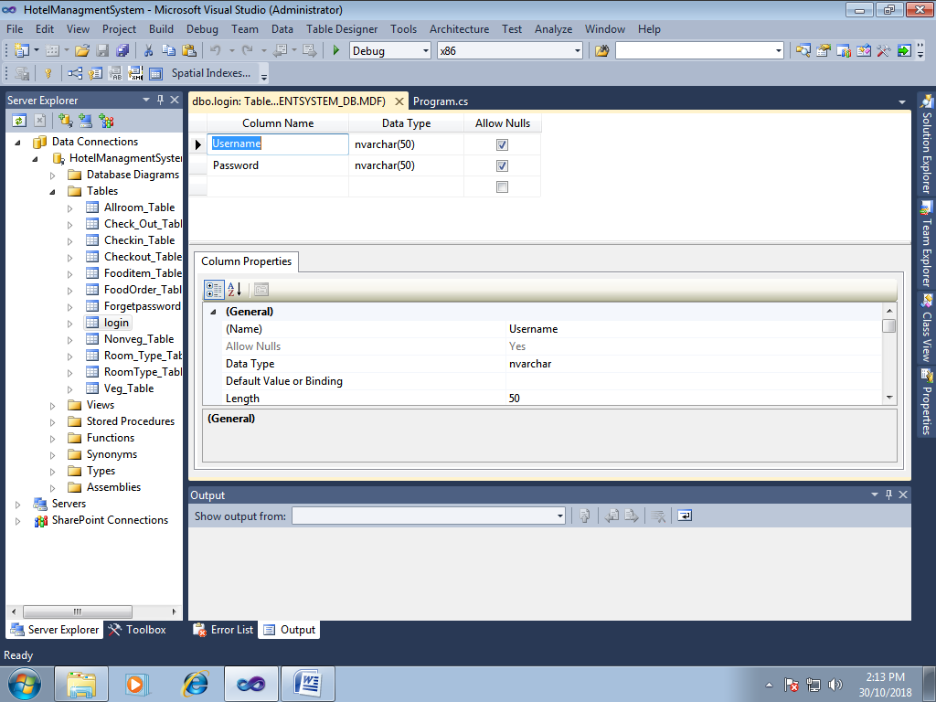

**Check in Table:**

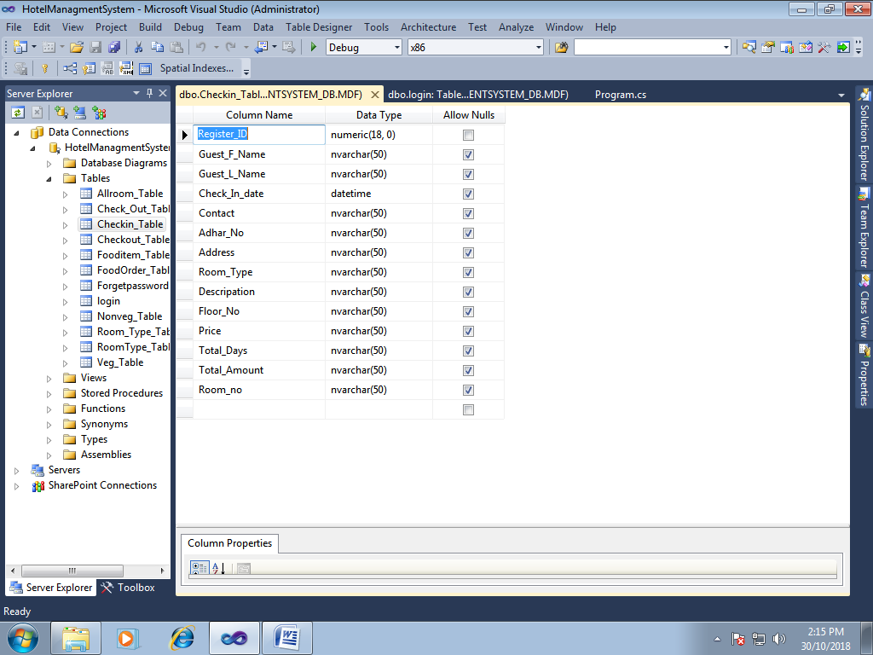

**All room Table:**

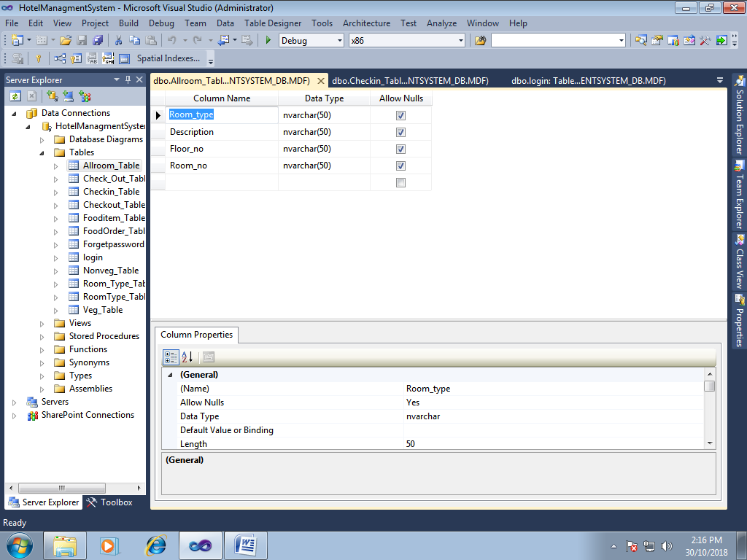

**Food item Table:**

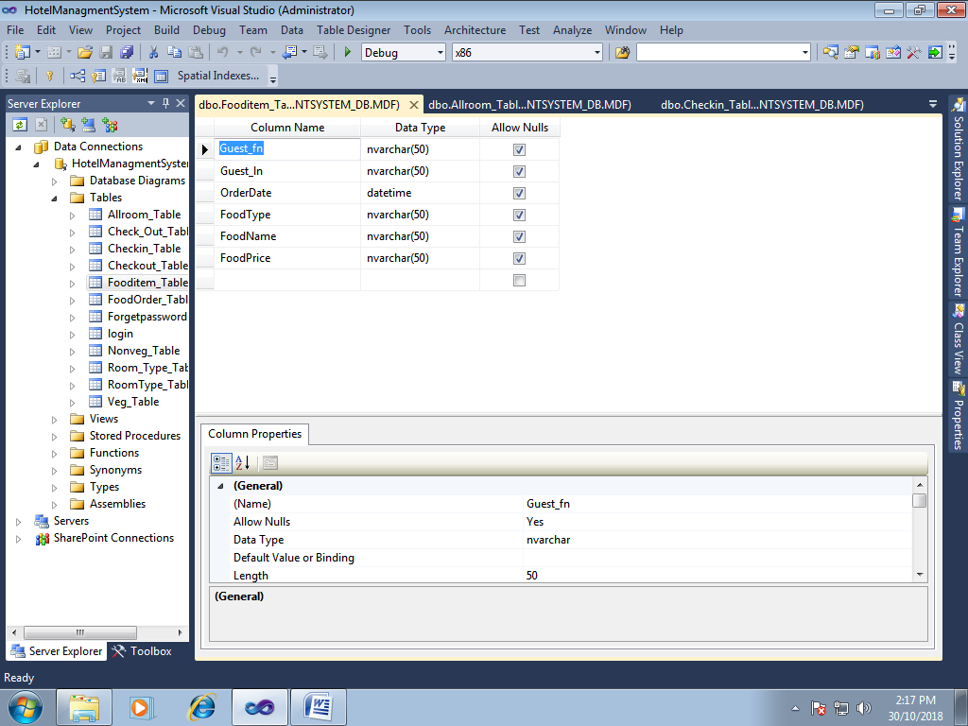

**Checkout Table:**

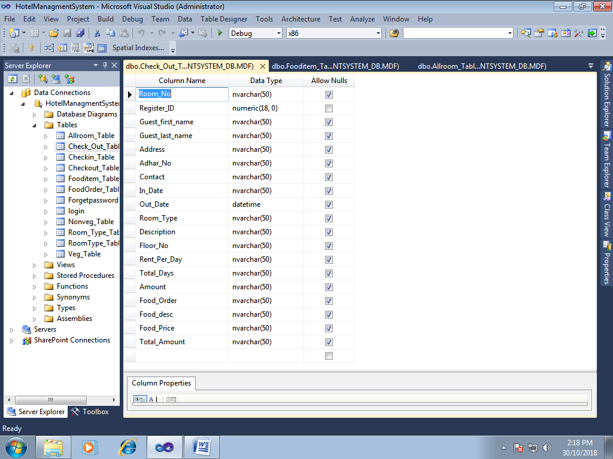

**Food order Table:**

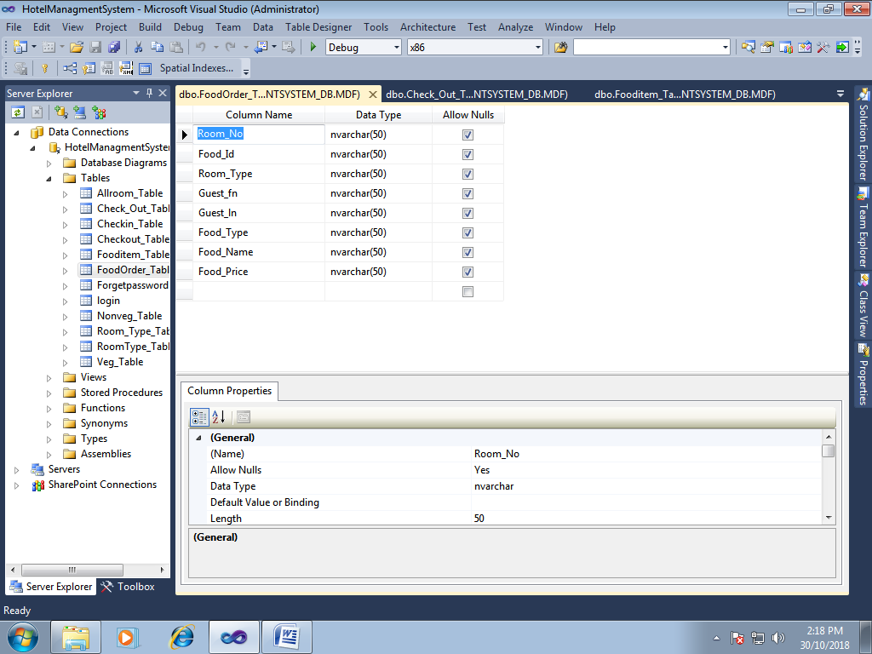

**Forget password Table:**

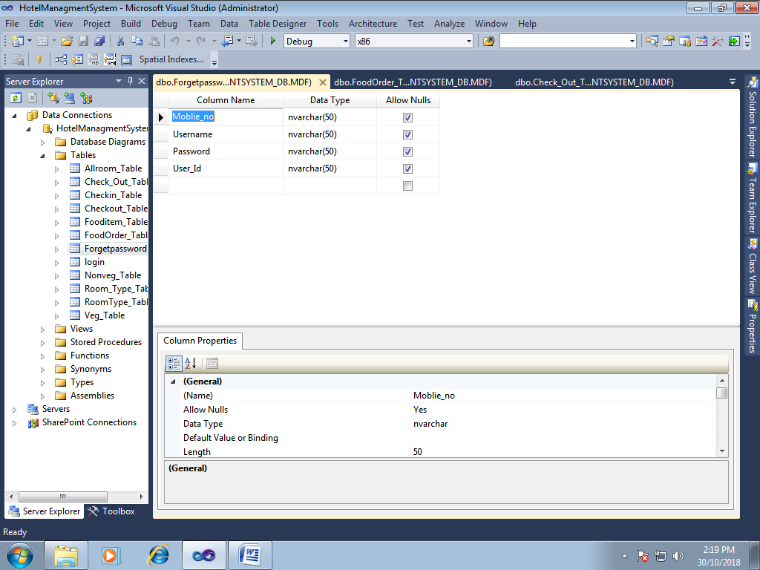

**4.2 ]Output Design:-**

**Login:**

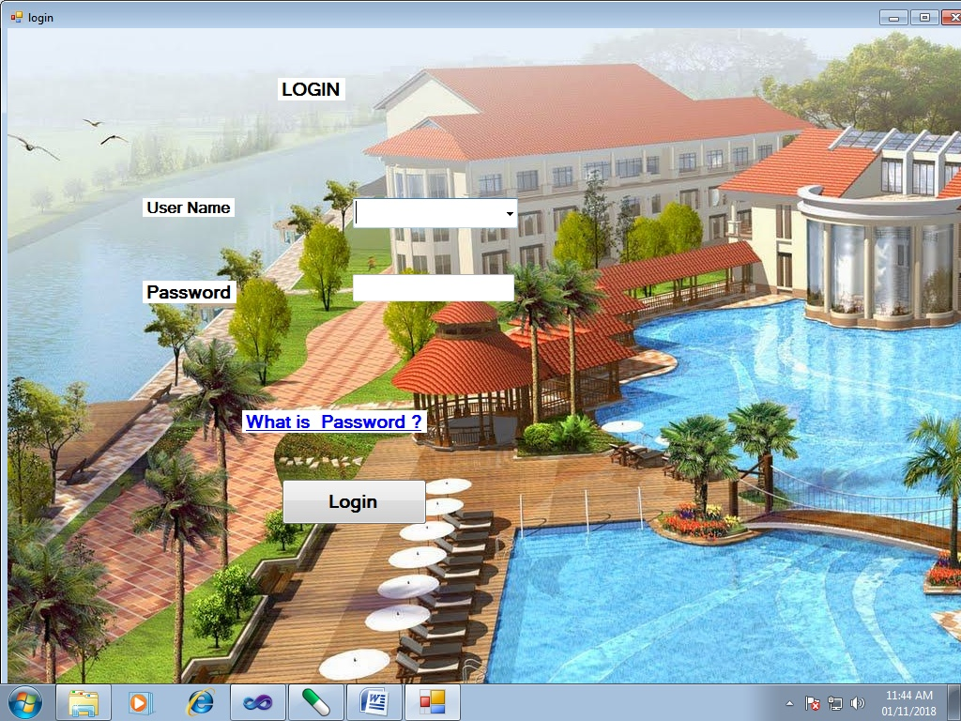**Main Page:**

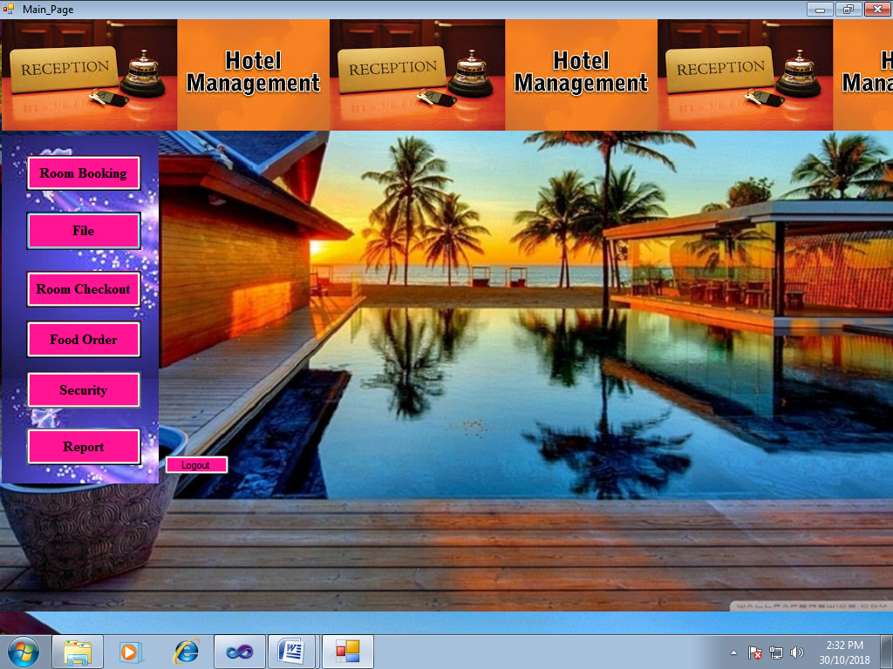

**4.2.1]Room Booking:**

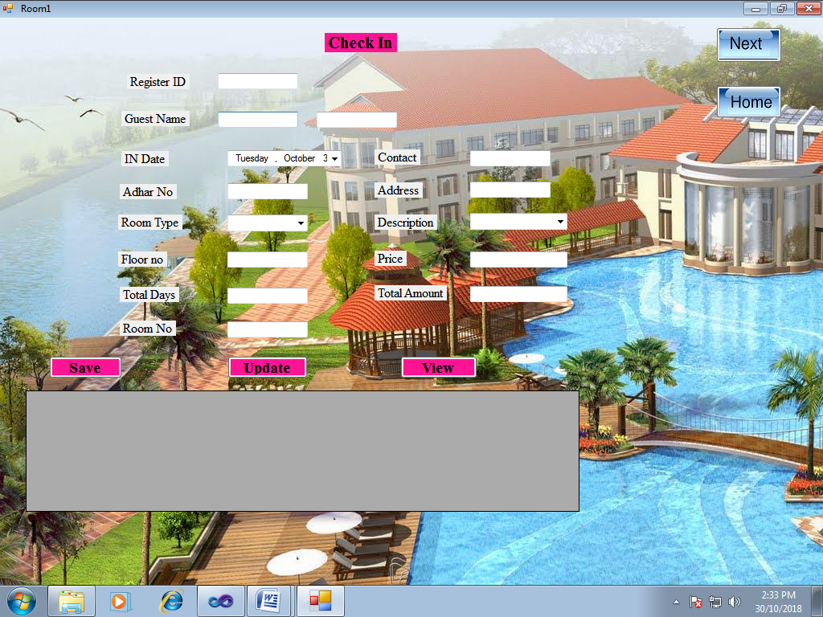

**Save:**

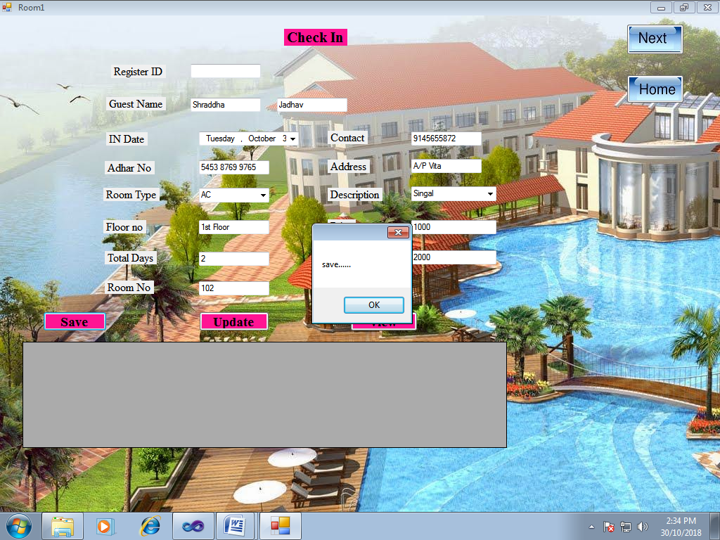

**Update:**

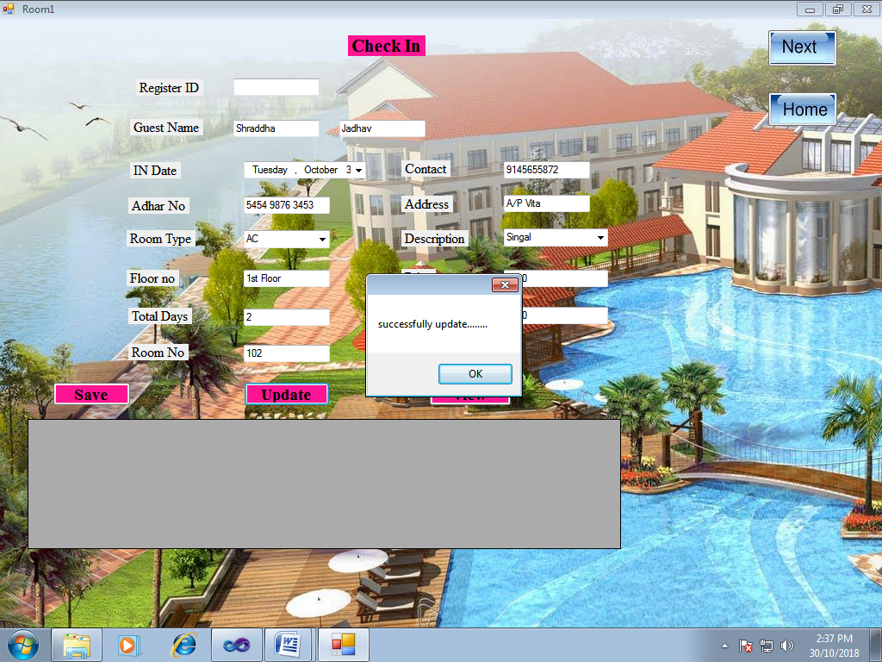

**View:**

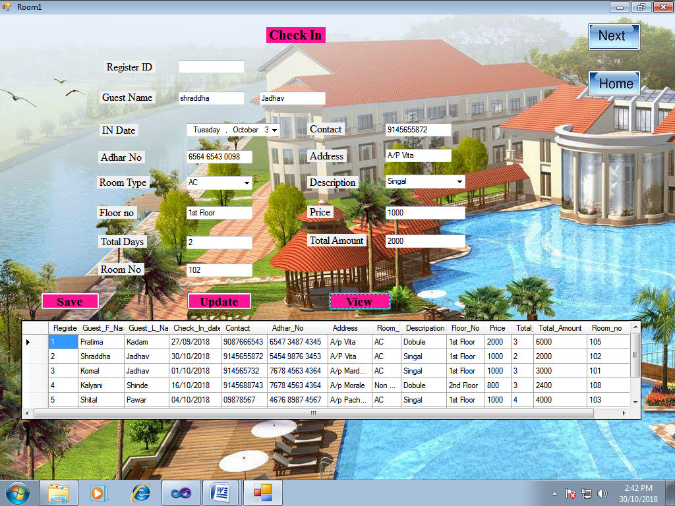

**4.2.2]File:**

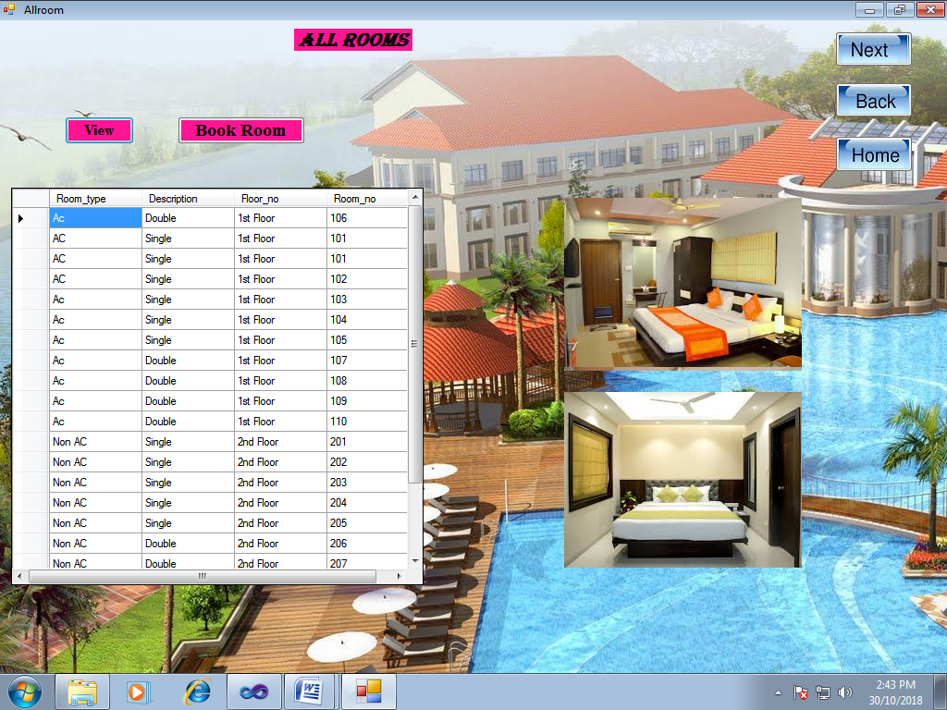

**4.2.3]** **Room Check Out:**

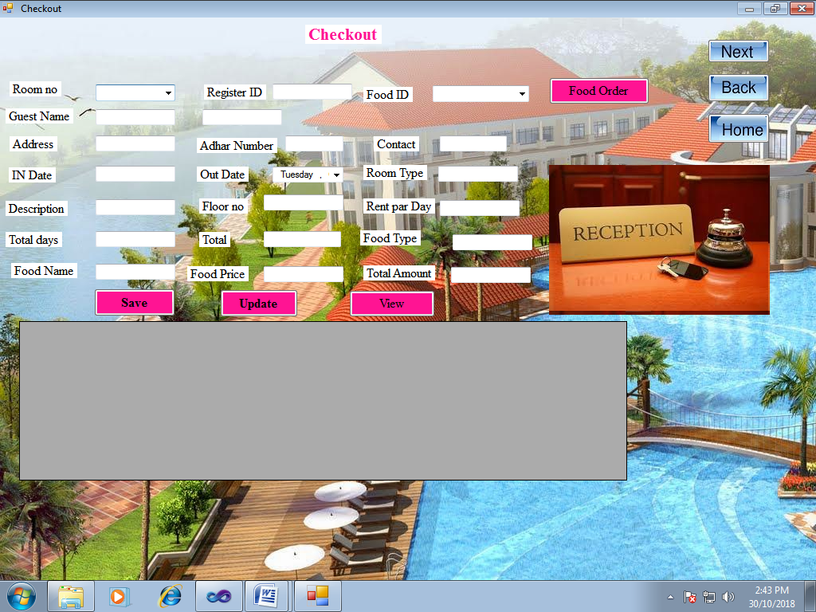

**Save :**

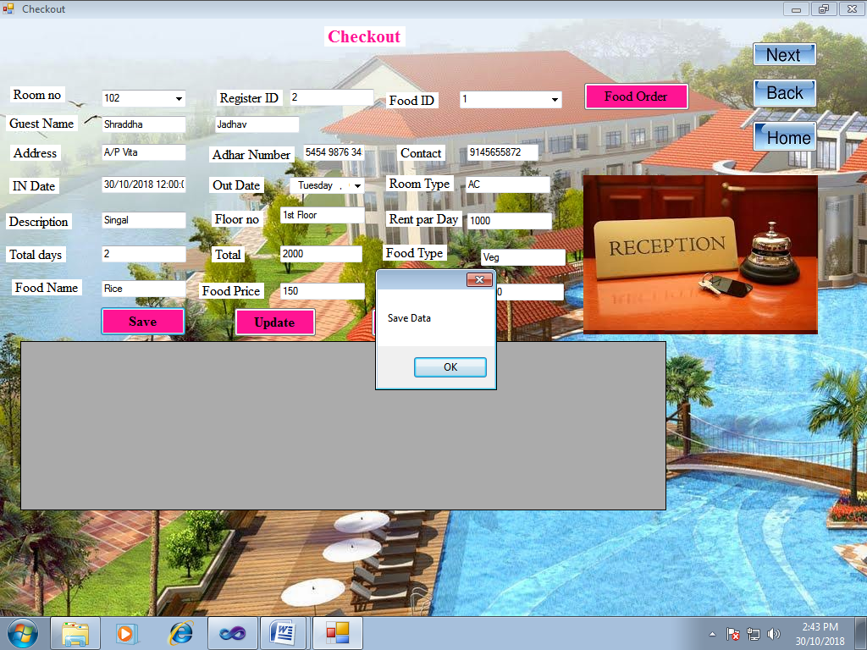

**Update :**

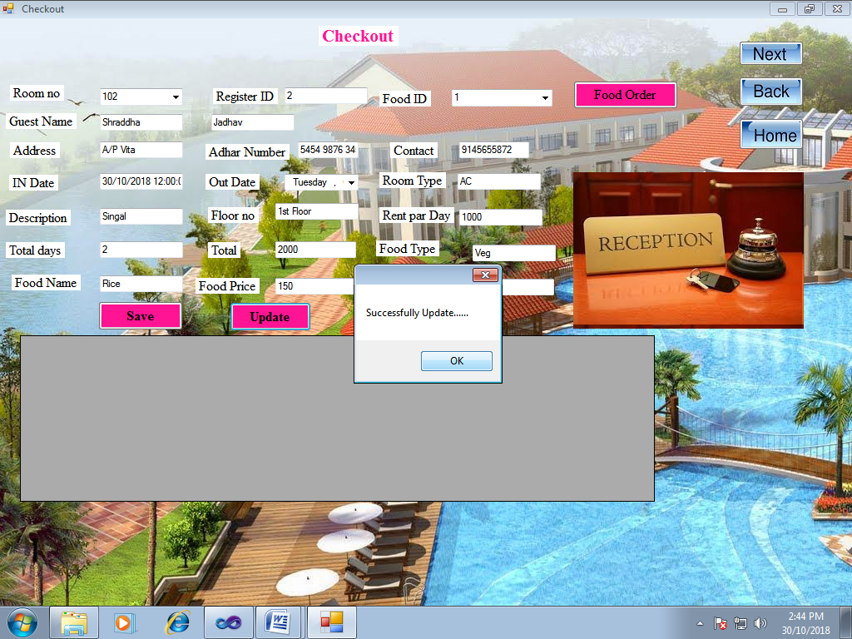

**View:**

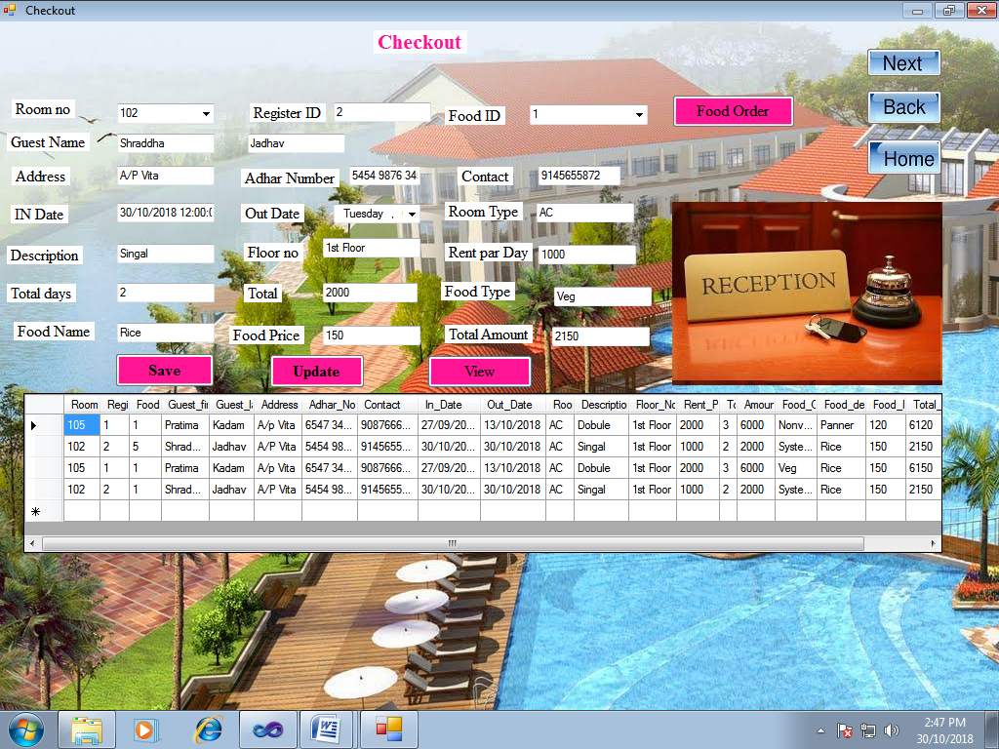 **4.2.4] Food Order:**

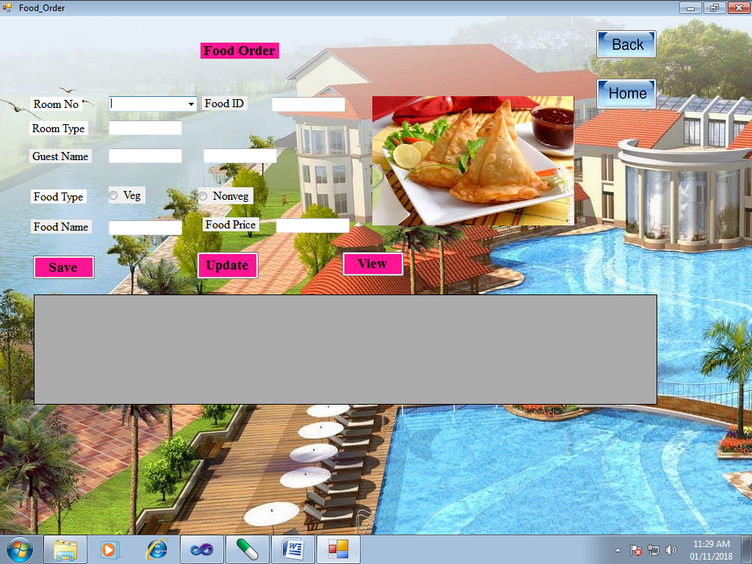

**Save :**

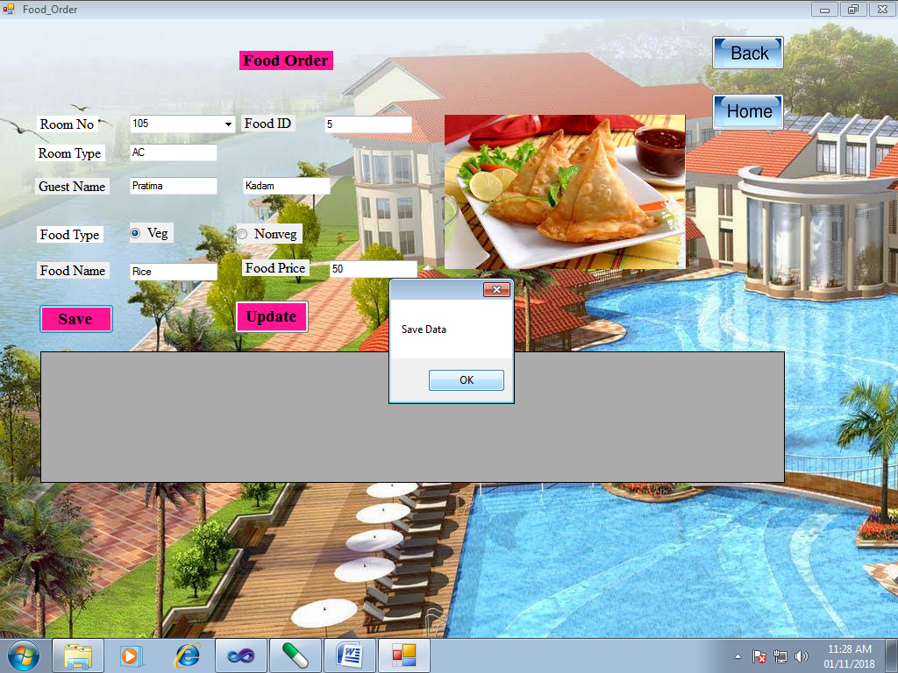

**Update :**

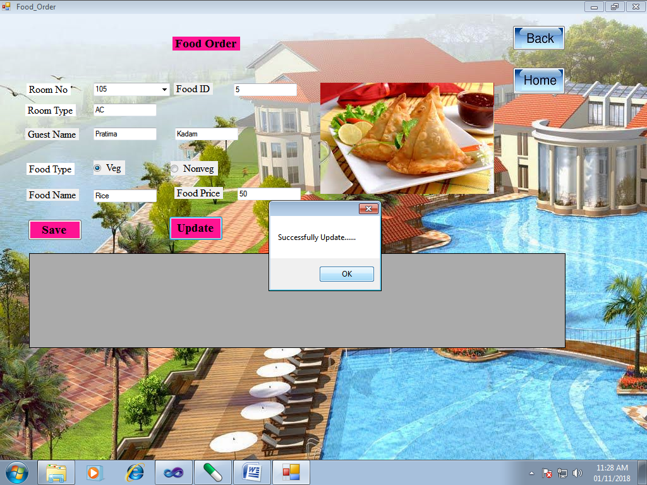

**View :**

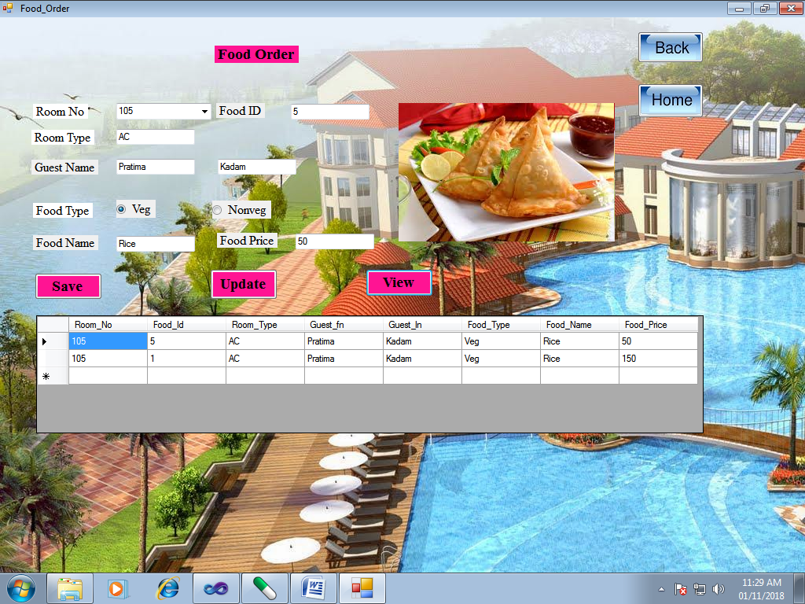

**4.2.5]Food item:**

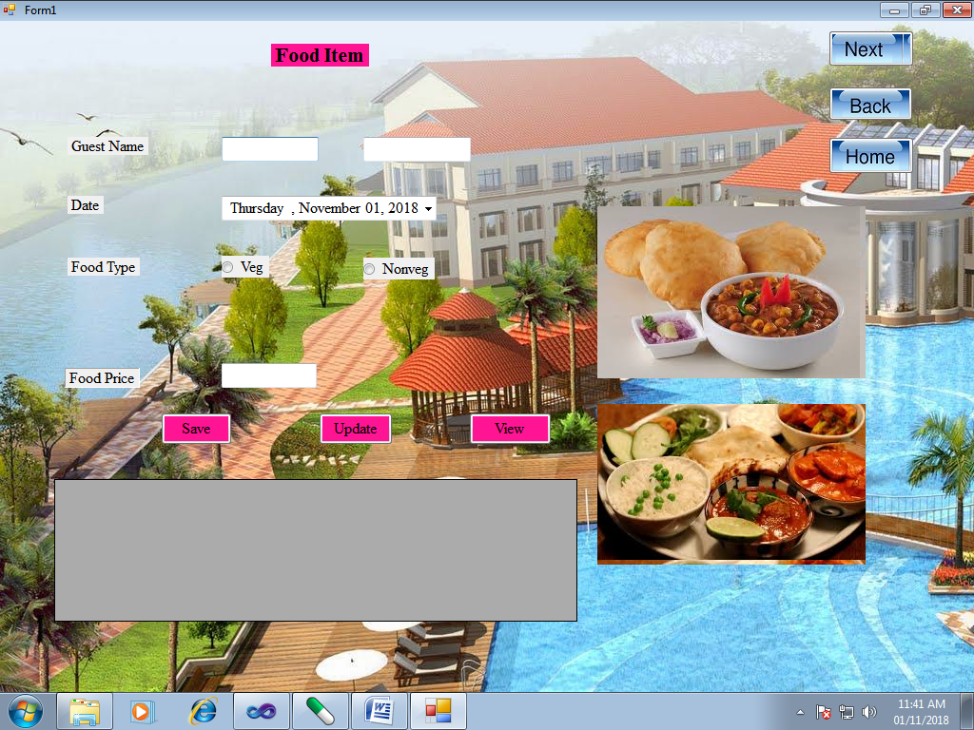

**Save :**

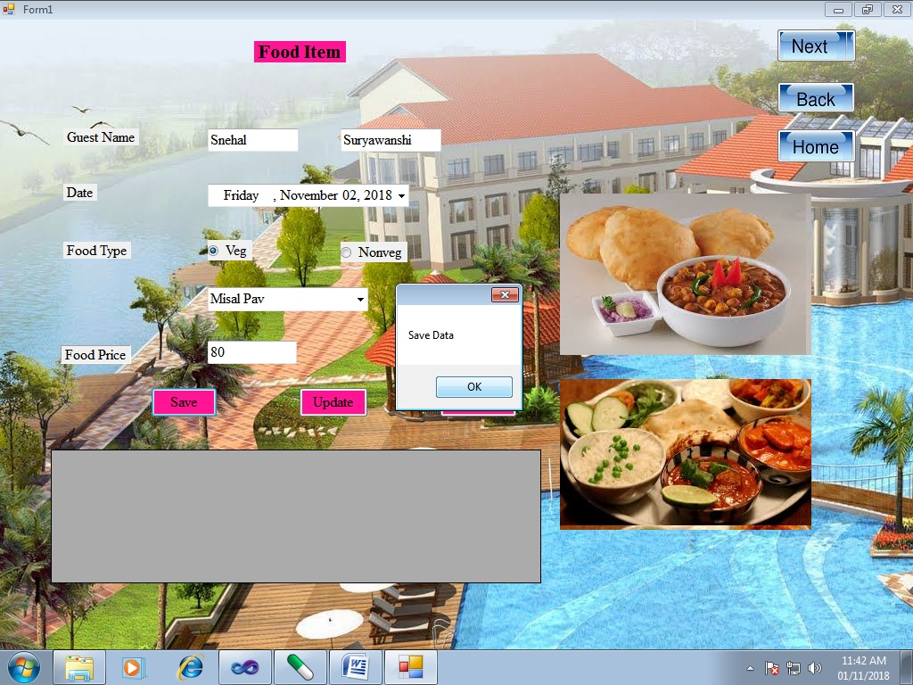

**Update :**

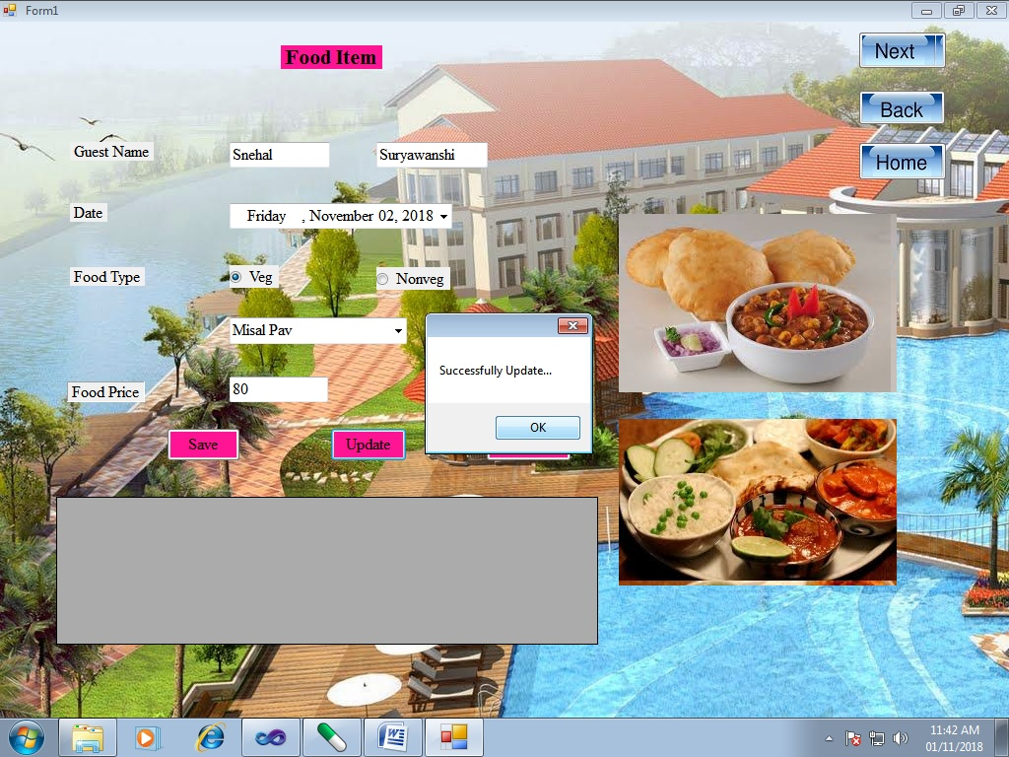

**View :**

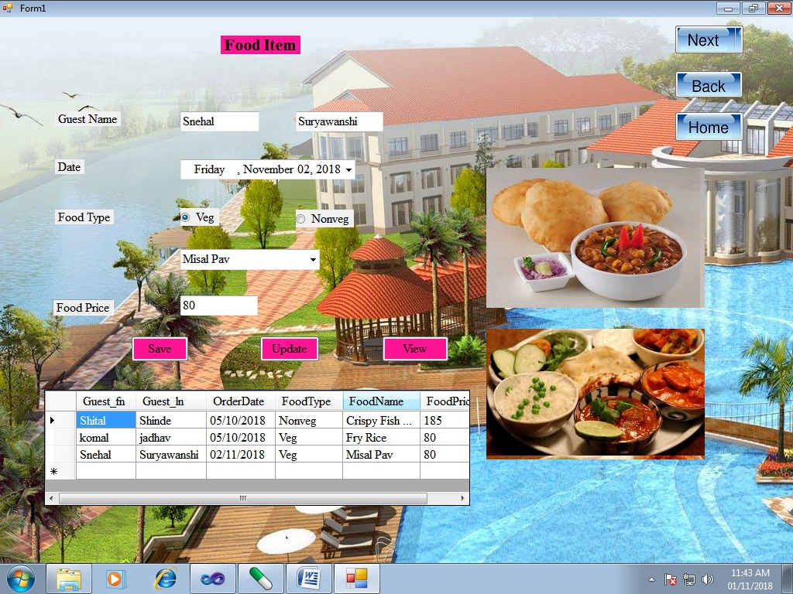

**4.2.6]Security:**

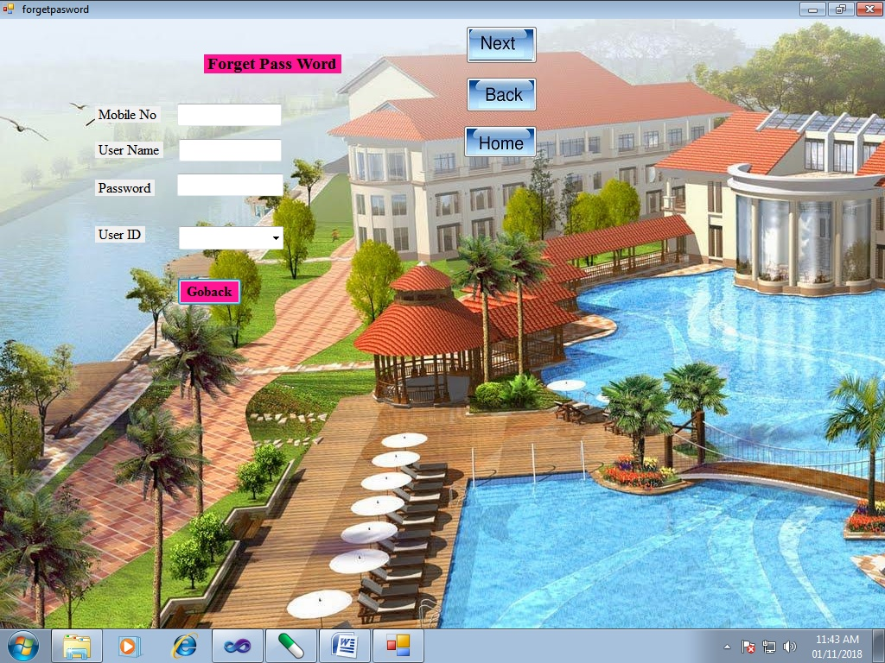

**Forget password:**

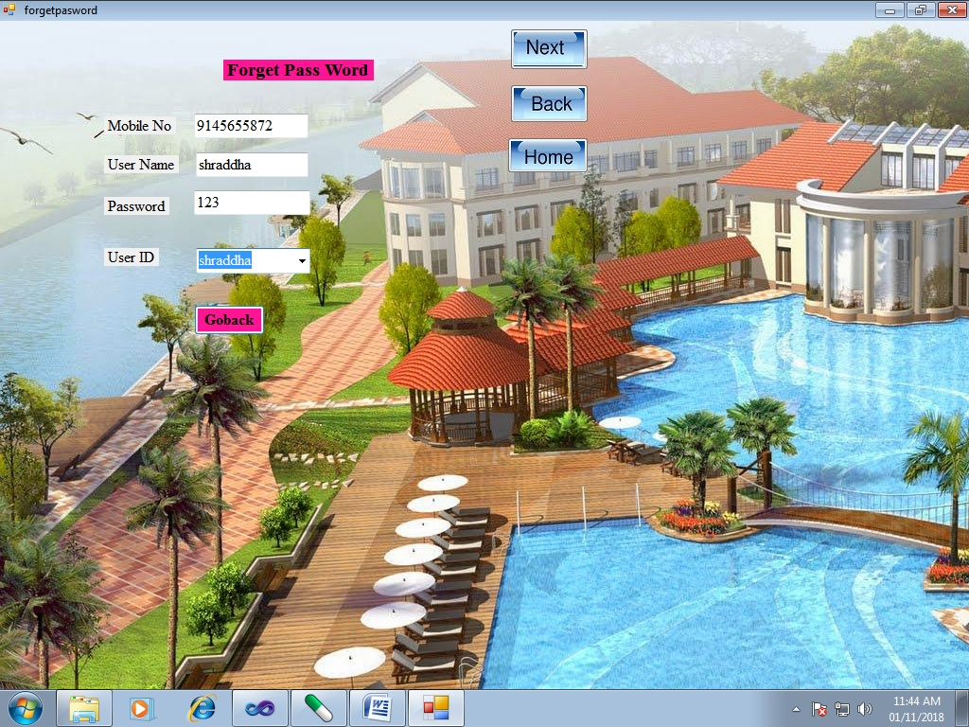

**Log in:**



**4.2.7]Report:**

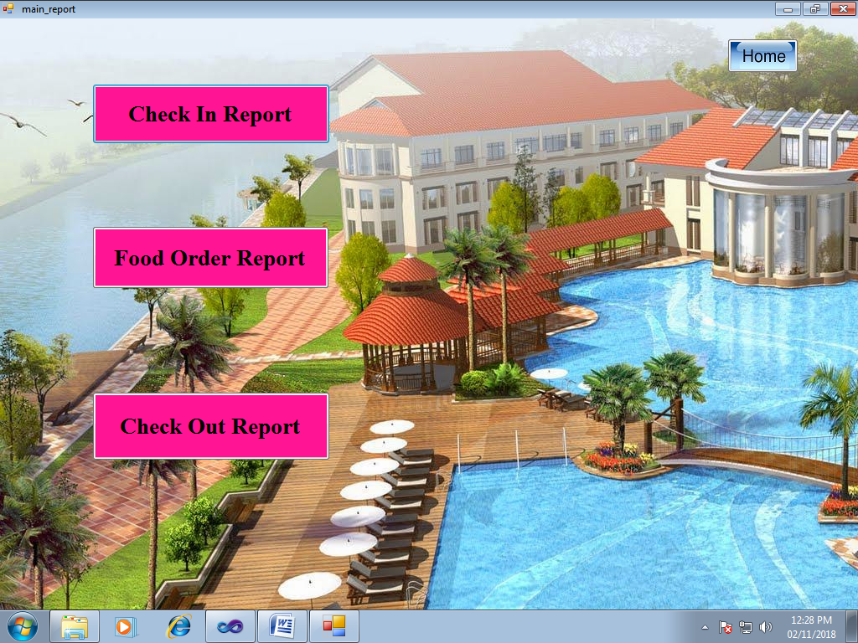

**Check In Report:**

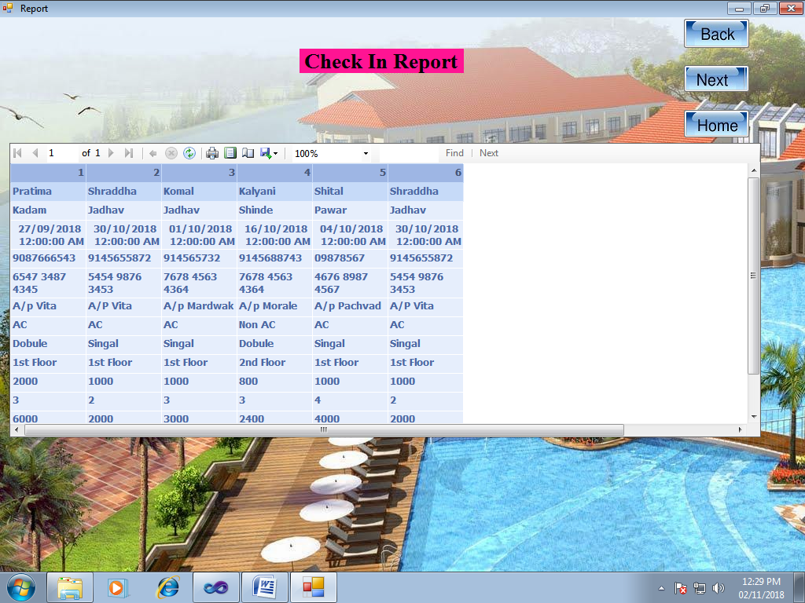

**Food Order Report:**

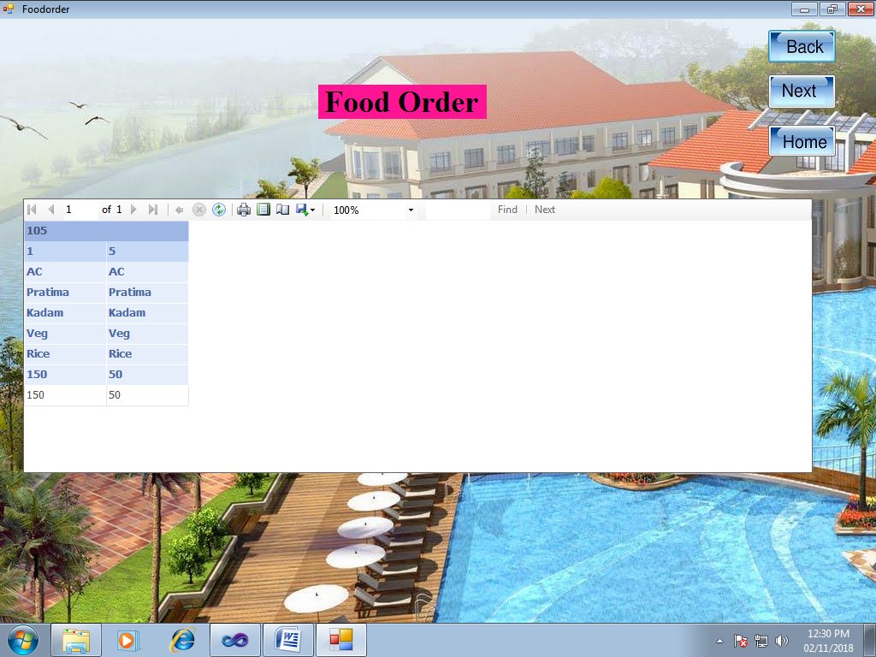**Check Out Report:**

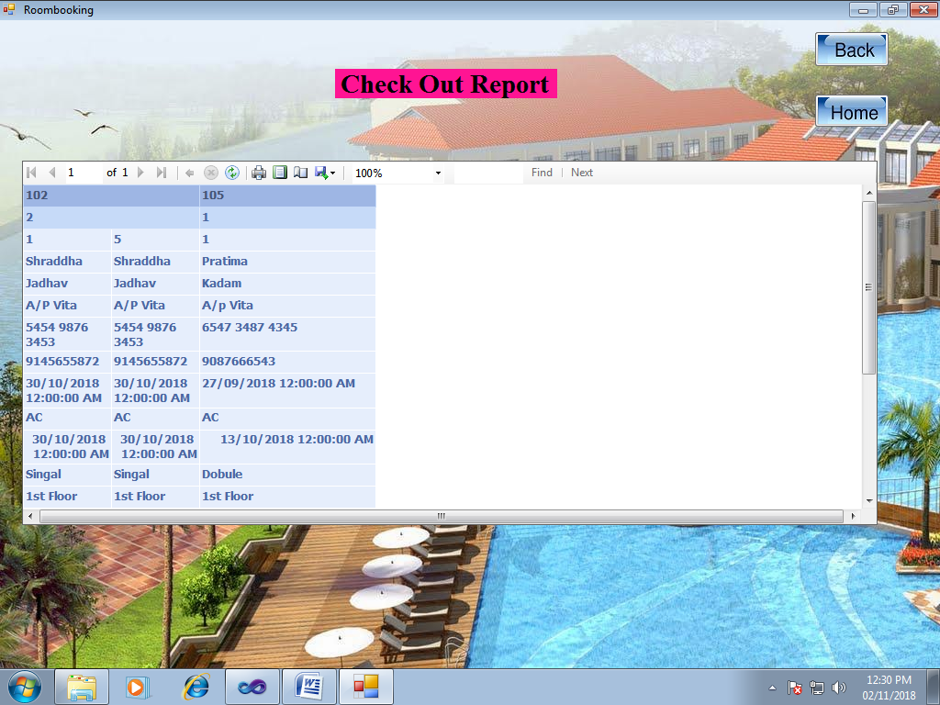

**5. IMPLEMENTATION**

**System Requirement.**

The minimum software and hardware requirments for complete project to run softcorner computer system.

**5.1 Hardware Requirment**

→ Processor: Pentium IV& Above

→RAM:- 512MB& above

→Hard disk: Enough space on the Hard disk.

→Monitor: Color any size

→Keyboard: Any type of keyboard.

→Mouse: Optical Mouse

→Printer: Laser Printer

**5.2 Software Requirments**

→Microsoft window XP or later versions

→Microsoft Visual Studio .Net 2010.

→Microsoft SQL Server 2008.

→Microsoft .NET Framework 4.0

**6. CONCLUSION AND SUGGESTIONS**

**6.1 Conclusion**:

This paper assists in modifying the existing system to site based system. This is a paperless work. It can be monitored and controlled remotely. It reduces the manpower required. It provides accurate information always. Malpractice can be reduced. All gathered and extra information can be saved and can be accessed at any time. The data which is stored in the project helps in taking intelligent and quick decisions by the management. So it is better to have a Web-Based Information Management system. All the stakeholders, **staff members can get the desired information without delay. This system is essential in the colleges/hostels and universities**

**6.2 limintations:**

1] The developed system is single user system.

2] The system is offline only.

3] The system is single user system.

4] The system is uni-language.

**6.3 Suggestions:**

1] More report can be added to improve the system.

2] More security features for reports and transactions can be added to the system.

3] All the other transactions carried out in the systems which are not included in the developed software can be considered in future.

4] Forms for purchase and sale returns can be modified to multi-user system.

5] The system will support online transactions.

6] The system will provide multi-user approach.

7] The system will available in multilanguage.

**7. BIBLIOGRAPHY**

**Books referred:**

1- The Visual Basic .Net

● Author: Steven Holzner.

2- An Integrated Approach to Software Engineering

● Author: Pankaj Jalote

3- Database Concepts

● Author: F. Korth

**Website:**

[www.google.com](http://www.google.com)

[www.codeproject.com](http://www.codeproject.com)